**Answer 1**

*First generation mobile communication*

The first generation of mobile communication was based on analog system. It was introduced in 1980 for the first time. Advanced mobile phone system (AMPS) was the first most popular analog systems and was launched in the United states of America. All of the standards in 1G use frequency modulation techniques for voice signals. The spectrum within cell was divided into number of channels which was not efficient in terms of the available radio spectrum, and this placed a limitation on the number of calls that could be made at any one time. Analog systems were based on circuit switching technology and offers only voice communication and no data communication. (Jyotsna Agrawal, 2015)

Main features and strengths of 1G

* It is based on analog system
* Supports data speed of up to 2.4 kbps
* (Jyotsna Agrawal, 2015)Example: cordless telephone

Weaknesses of 1G

* supports only voice and no data communication
* Low capacity
* Poor handoff mechanism
* Poor security
* Poor quality voice link

*Second generation mobile communication*

2G was an improvement over 1G and was introduced in late 1980s. It was based on low band data signaling. Time Division Multiple Access (TDMA) and Code Division Multiple Access (CDMA) replaced the analog technology. GSM (Global systems for mobile communications) is the most popular 2G wireless communication system. It can support multiple users. The TDMA breaks down data transmission, such as a phone conversation, into fragments and transmits each fragment in a short burst, assigning each fragment a time slot. With a cell phone, the caller does not detect this fragmentation. During development over more than 20 years, GSM technology has been continuously improved to offer better services to its users. GSM supports 450 million cellular subscribers, with international roaming in approximately 140 countries and 400 networks. CDMA uses spread spectrum technology to break up speech into small, digitized segments and encodes them to identify each call. The CDMA distinguishes between multiple transmissions carried simultaneously on a single wireless signal. It carries the transmissions on that signal, freeing network room for the wireless carrier and providing interference-free calls for the user. The CDMA breaks down calls on a signal by codes, whereas TDMA breaks them down by time. The result in both cases is an increased network capacity for the wireless carrier and a lack of interference for the caller.

Main features and strengths of 2G

* Better spectrum efficiency
* Provides data rate up to 64 kbps
* Improved system capacity and network coverage
* Roaming facility
* Voice and data services both available
* Improved security

Weaknesses of 2G

* Does not support high data rates
* Weak digital signal
* Unable to handle complex data

*Third generation mobile communication*

3G was one of the biggest change in the world of wireless communication. The 3G fulfils the specifications of International Mobile Telecommunications-2000 (IMT2000), the official International Telecommunication Union which intended to provide wireless access to global telecommunication system. To meet the IMT-2000 standards, a system is required to provide peak data rates of at least 200 Kbit/s. The most important IMT-2000 proposals are the Universal Mobile Telecommunications System (UMTS) as the successor to GSM. The UMTS uses the W-CDMA, TD-CDMA, or TD-SCDMA air interfaces in which WCDMA is the most popular air-interface technology for the UMTS. The main components include BS (Base Station) or nod B, RNC (Radio Network Controller), apart from WMSC (Wideband CDMA Mobile Switching Centre) and SGSN/GGSN. The W-CDMA gives additional advantages of high transfer rate, and increased system capacity and communication quality by statistical multiplexing. The WCDMA utilizes efficiently the radio spectrum, because the CDMA technique enables all base stations to use the same frequency. In the WCDMA system, the data is split into separate packets, which are then transmitted using packet switching technology, and the packets are reassembled in the correct sequence at the receiver end by using the code that is sent with each packet. The UMTS systems are designed to provide a range of data rates, depending on the user’s circumstances, providing up to 144 kbps for moving vehicles, up to 384 kbps for pedestrians and up to 2 Mbps for indoor or stationary users. The3G basically focused on multimedia applications such as video calling, videoconferencing for mobile phones, improved capacity, world roaming, low cost, better compatibility, high speed data.

Main Features and strengths of 3G

* Faster data rates
* Supports multimedia applications like video and photography
* Value added services like mobile television, GPS, Video call and conferencing
* High speed mobile internet access
* Internet capacity

Weaknesses of 3G

* Requires 3G compatible handsets
* The cost of upgrading to 3G devices is expensive
* Power consumption is high
* 3G requires closer base stations which is expensive

*Fourth generation mobile communication*

In order to cater the higher data requirements, efforts were made to improve the downlink and uplink throughput rates by applying higher modulation techniques. Long Term Evolution Project(LTE) was launched by 3GPP to ensure the continuous competitiveness of the UMTS in the future. As LTE is considered as the evolution of universal mobile telephone system (UMTS), hence LTE’s equivalent components are thus named evolved UMTS terrestrial radio access (EUTRA) and evolved UMTS terrestrial radio access network (EUTRAN). The basic architecture of LTE contains a separate IP connectivity layer for all the IP based services and Evolved Packet System (EPS) which handles the overall communication procedure. LTE is IP based system. LTE is very flexible when it comes to connectivity. An operator with a GPRS/EDGE network or aNon3GPP systems can connect to a LTE network. Due to this increased flexibility, LTE is the choice of majority of operators worldwide. By using Orthogonal Frequency Division Multiple Access (OFDMA), LTE will be able to provide download rates of about 100 Mbps for multi-antenna (2x2), multiple-input multiple output (MIMO) for the highest category terminals. For these terminals upload rate is about 50 Mbps. Moreover, it provides better mobility, efficient radio usage, high level of security, flexible spectrum utilization, reduced delay/latency, cost efficient deployment and various other advantages which makes LTE more reliable and user friendly.

Main Features and strengths of 4G

* High Spectral efficiency
* High voice quality
* Easy access to internet and streaming video
* Low latency
* Simple architecture
* Efficient multicast/broadcast

Weaknesses of 4G

* Higher data prices for the consumers
* Very expensive and hard to implement
* Complex hardware
* More power usage

**Answer 2**

**Ground wave propagation:**

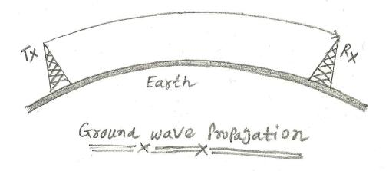

Ground wave propagation operates below 2 MHz frequency. It covers ELF, SLF, ULF, VLF, LF, and MF frequency bands. This kind of signal exists very close to surface of the earth. It follows earth’s contour and hence can propagate to considerable distances. At lower frequencies, interference occurs due to atmospheric noise only. The power of transmission here is sufficient and hence maximum range of about 5000 miles can be achieved. Optimum antenna size is about λ/2. As the distance from transmitter increases received signal strength decreases and follows exponential curve. (http://www.rfwireless-world.com/Terminology/sky-wave-vs-LOS-wave-vs-ground-wave.html)

They are also known as surface waves. They are used up to maximum frequency range.   
Example: AM radio

**Sky wave propagation:**

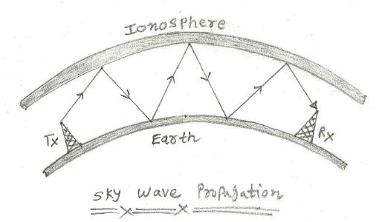

Sky wave operates between 2 MHz to 30 MHz range of frequency and covers ELF, SLF, ULF, VLF, LF, MF, and HF frequency bands. It exists in the sky and is dependent upon reflective characteristics of ionosphere layer. The signal is reflected from ionized layer of the atmosphere. In this propagation mode, signals can travel number of hops, back and forth. The example of this type is SW (Shortwave) radio. Sky wave travels larger distances during night time since ionosphere is closer to earth’s surface during night. It travels at a flatter angle. There are more skip zones which results into no reception. During the daytime, ionosphere layer is away from the earth surface. It travels with an angle. It travels smaller distances. There are less skip zones with no reception.

**Line of sight propagation**

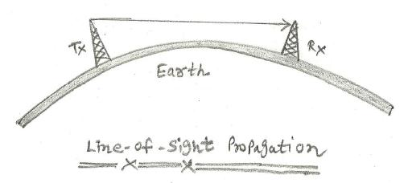

Line of sight propagation exist from above 30 MHz and covers VHF, UHF, SHF, and EHF frequency bands. LOS wave travels in straight line. propagation follows laws of free space. Both transmitting antenna and receiving antenna must be within LOS (Line of Sight). Examples are satellite communication and ground communication.

In the VHF band, LOS signal will be affected by reflection of various objects on the earth.

**Non-Line of sight propagation**

Non-line of sight is a term often used when the radio transmitter and receiver are not in the direct visual line of sight, and this is dealt with by the use of multiple paths in signal propagation. Non-line of sight can be overcome with the use of antennas and other such communication devices. Distance also plays a significant role in lowering the receiving power of a signal, leaving a poor transmission system. Modern computer networking’s biggest concern is to effectively reduce the NLOS, and this is done on wireless networks by using relays at various points so that the signal is transmitted around the obstruction without loss of data or transmission quality. Multipath signal propagation is also widely used. (https://www.techopedia.com/definition/5077/non-line-of-sight-nlos)

**Answer 3**

**Reflection**

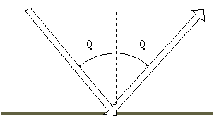

When a plane wave encounters a change in medium, some or all of it may propagate

into the new medium or be reflected from it. The part that enters the new medium is

called the transmitted portion and the other the reflected portion.  The part which

is reflected has a very simple rule governing its behavior.

Angle of Incidence = the angle between the direction of propagation and a line perpendicular to the boundary, on the same side of the surface. Angle of Reflection = the angle between the direction of propagation of the reflected wave and a line perpendicular to the boundary, also on the same side of the surface. Then the rule for reflection is simply stated as:

*The angle of reflection = The angle of incidence*

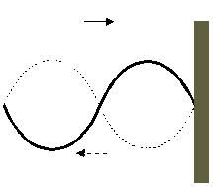

If the incident medium has a lower index of refraction, then the reflected wave has a 1800 phase shift upon reflection. Conversely, if the incident medium has a larger index of refraction the reflected wave has no phase shift

**Diffraction**

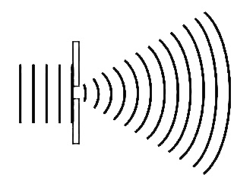

We observe the phenomenon of waves bending around corners every day, e.g. when we hear sound from sources that are out of sight around a corner. Light can also bend around corners. When light from a point source falls on a straight edge and casts a shadow, the edge of the shadow is not a perfectly sharp step edge. Neither is the shadow of the edge just smeared out. There is some light in the area that we expected to be in the shadow, and we find alternating bright and dark fringes in the illuminated area close to the edge. This is the result of interference between many light waves (Huygens’ Principle). Such effects are referred to as diffraction.

**Scattering**

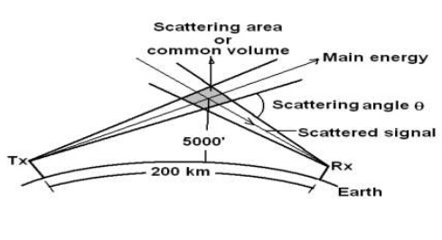

Scattering is a physical process that causes radiation to deviate from a straight trajectory. We saw this in the introductory sections on reflection: If there were microscopic irregularities in the surface we would get diffuse instead of specular reflection. The same goes for radiation passing through a transparent medium: If there are non-uniformities like particles, bubbles, droplets, density fluctuations etc., some of the radiation will deviate from its original trajectory. In a physical description of the phenomenon, we distinguish between two types of scattering, namely elastic and inelastic. Elastic scattering involves no (or a very small) loss or gain of energy by the radiation, whereas inelastic scattering does involve some change in the energy of the radiation. If the radiation is substantially or completely extinguished by the interaction (losing a significant proportion of its energy), the process is known as absorption. When radiation is only scattered by one localized scattering center, this is called single scattering. Single scattering can usually be treated as a random phenomenon, often described by some probability distribution. (Albregtsen)

**Answer 4**

**Coherence Bandwidth**

is a statistical measurement of the range of frequencies over which the channel can be considered "flat", or in other words the approximate maximum bandwidth or [frequency](https://en.wikipedia.org/wiki/Frequency) interval over which two frequencies of a signal are likely to experience comparable or correlated amplitude fading.

It can be reasonably assumed that the channel is flat if the coherence bandwidth is greater than the data signal bandwidth. The coherence bandwidth varies over [cellular](https://en.wikipedia.org/wiki/Cellular_network) or [PCS](https://en.wikipedia.org/wiki/Personal_Communications_Service) communications paths because the multipath spread *D* varies from path to path.

(Wikipedia)

We can determine the value of Coherence bandwidth by following formula with depends on RMS delay spread.



Frequencies within a coherence bandwidth of one another tend to all fade in a similar or correlated fashion. One reason for designing the CDMA IS-95 waveform with a bandwidth of approximately 1.25 [MHz](https://en.wikipedia.org/wiki/Megahertz) is because in many urban signaling environments the coherence bandwidth *B*c is significantly less than 1.25 MHz. Therefore, when fading occurs it occurs only over a relatively small fraction of the total CDMA signal bandwidth. The portion of the signal bandwidth over which fading does not occur typically contains enough signal power to sustain reliable communications. This is the bandwidth over which the channel transfer function remains virtually constant.

If the delay spread *D* over a particular cellular communication path in an urban environment is 1.9 µs, then using equation above, the coherence bandwidth is approximately 0.53 [MHz](https://en.wikipedia.org/wiki/Megahertz), which results in frequency selective fading over the IS-95 bandwidth.

**Coherence Time**

is the time duration over which the channel impulse response is considered to be not varying.

In other words, coherence time is the time duration over which two received signals have a strong potential for amplitude correlation. If the reciprocal bandwidth of the baseband signal is greater than the coherence time of the channel, then the channel will change during the transmission of the baseband message, thus causing distortion at the receiver. Such channel variation is much more significant in [wireless](https://en.wikipedia.org/wiki/Wireless) communications systems, due to [Doppler effects](https://en.wikipedia.org/wiki/Doppler_effect).

Distortion occurs if the period of the baseband signal is greater than the coherence time. This happens because the channel will change during the transmission of the signal and will be variant as duration of the symbol period is more than the coherence time.

We can determine the value of Coherence time by following formula:



We can classify the multipath time delay spreading into two parts:

1. Frequency flat fading
2. Frequency slow fading

**Frequency flat fading**

Frequency flat fading occurs when B S which denotes the bandwidth of the signal is much smaller than *B*c - the coherence bandwidth. This implies that sigma tau which is the RMS delay spread is much less than ‘TS’ - the symbol duration. Now sigma tau is only a function of the environment. It has nothing to do with the signal. So if in a small room environment with lot of reflectors, if sigma tau is much smaller than tau S, then in that case we will experience something called as a ‘frequency flat fading’. In these scenarios, we typically find that the received amplitude to be statistically distributed either as a Rayleigh or Ricean. The spectral characteristics of the transmitted signal is preserved in the case of flat fading

**Frequency selective fading**

Frequency selective fading occurs when the bandwidth of the signal is greater than the Coherence bandwidth i.e. *B*c

it equally implies that sigma tau should be greater than ‘T S’ the symbol duration. in this case intersymbol interference occurs. The other features of a frequency selective channel is that the spectral characteristics of the transmitted signal is not preserved. This is the major impediment but it can be also viewed from the other side of the coin which is, you can have uncorrelated fading for one part of the signal with respective the other part of the bandwidth.

**Answer 5**

1. 90% coherence bandwidth *B*c = 1 / 50σ = 1/ (50 x 4us) = 5 kHz
2. Max Doppler shif can be calculated using the below formula:



Where fc = carrier frequency

v = velocity of vehicle

v in m/s = 250 x 0.28 = 70

D=(5×10e6× 70)/(3×10e8)= 1.17

1. 50% coherence bandwidth *B*c = 1 / 5σ = 1/(5 x 4us) = 50 kHz
2. Since symbol duration (66.7us) >> rms delay spread i.e. σ (4us)

* This is frequency flat fading

**Answer 7**

Frequency Shift Keying (FSK) **advantage** over Phase Shift Keying (PSK):

FSK has lower probability of error (Pe).

Frequency Shift Keying (FSK) **disadvantage** over Phase Shift Keying (PSK):

FSK uses larger bandwidth compared to PSK. Hence it is not bandwidth efficient.

Reason why CPFSK is preferred over FSK:

CPFSK is constrained to maintain continuous phase at its symbol time boundaries. This constraint offers important advantages in error rate performance as well as signal spectrum containment. Also, continuous phase is desirable for signals that are to be transmitted over a bandlimited channel, as discontinuities in a signal introduce wideband frequency components.

**How could the continuous phase be achieved?**

The FSK is memory less process. No record is kept for symbol to symbol accumulation. In case of CPFSK, the phase is accumulated from symbol to symbol to maintain a smooth phase transition. This is how a continuous phase is achieved.

**Answer 8**

20dBW =100 W







**Answer 9**

Survey on: *Smart Antennas and Beamforming*

Papers used for this survey report:

1. Smart Antennas in Wireless Communications: Base Station Diversity and Handset Beamforming

By: *Naflali (Tuli) Herscovici, Christos Christodoulou, Carl B. Dietrich, Jr., Warren L. Stutzman, Byung-Ki Kim, and Kai Dietze*

From: *Virginia Tech Antenna Group, Electrical and Computer Engineering Department, Blacksburg*

1. Sequential Studies of Beamforming Algorithms for Smart Antenna Systems

By: *S.F. Shaukat, Mukhtar ul Hassan, R. Farooq, H.U. Saeed and Z. Saleem*

From: *Department of Electrical Engineering, COMSATS, Abbottabad, Pakistan 1 Brunel University, Uxbridge, United Kingdom (UK)*

Introduction

Smart Antenna in the field of wireless mobile communication has attracted a huge amount of interest from all over the world in recent years. The demand for wireless communication has risen rapidly in the last few years with increasing access of internet and multimedia file sharing. In order to meet this demand, the limited capacity systems like Single input single output(SISO) are being considered to be replaced by systems like Mutiple Element Antenna(MEA). The benefit of using multiple antennas is increase in communication reliability, rapid increase in data rate by spatial multiplexing etc.

A smart Antenna